What do I want you to do for today?

Your mid-term assignment is due soon. So let’s start working on it now.

You have three features for ASP.net and three for PHP. Each feature needs three documents: the narrative description, the data flow model, and the wireframe.

I want you to start writing out your narrative descriptions and your dataflow model.

Here is an almost complete example of what I am expecting from you at mid-term.

Let’s say I am creating a database driven testimonials features. I believe this would be a tier one feature.

Narrative description.

The testimonial feature is a means by which the hospital can solicit and display testimonials from satisfied patients and their families. Visitors to the Web site will see a link called “Testimonials” and be able to click on the link and view testimonials from other patients who have received services from the hospital that will encourage them to feel good about coming to the hospital and getting well.

The testimonials feature will have an administrative backend that will manage the testimonials. By managing the testimonials we mean that received testimonials can be approved, published, and removed from display. Testimonials can be left by anyone but must be approved by the administrator before they can be seen on the Web site. Administrative users will have to login to the Web site and then choose “Testimonials” from the available links. They would then see a list of links, with pagination, for the testimonials and the option to choose one to edit or add a new one. Administrators can also block and remove testimonials.

The database will look like this:

Primary key | Numeric
Date | Date
Text | Text 255 characters
Department | Text 100 characters
User | Text 100 characters
Publish | True/false

The dataflow models

Here is how “add new testimonial” data flow model would look:

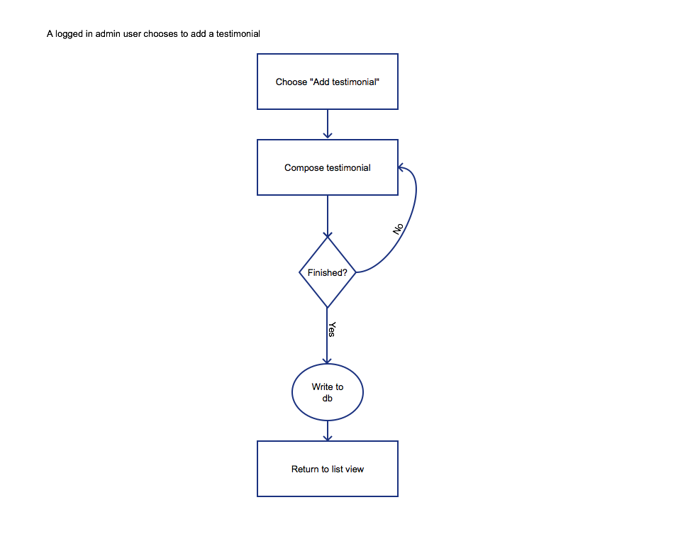
We have established that this is a logged in user and this user will make a choice: “add testimonial”. Composing the testimonial is next and then it is a matter of whether they are finished or not. The “yes” arrow assumes that the user saves the document. Which means there is a “Save” button. The circle is our call to save to the database and our outcome is to return to the list view of the testimonials.

Editing a testimonial would look like this:

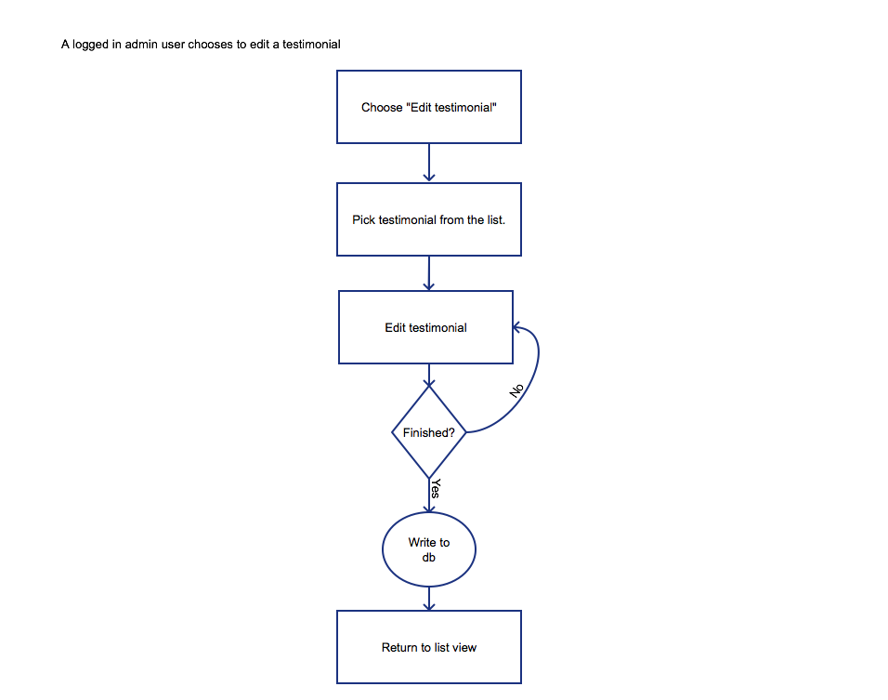

This dataflow model is almost identical to the first. It has one more box – “Pick testimonial from list”. As you develop your dataflow models you do not have to recreate each one from scratch but develop one and edit the others. You want to make sure you have dataflow models for each significant interaction between the user and the Web site.

In our case we would have another dataflow model for approving testimonials and deleting testimonials. Can you think of any others?

In using the modeling and prototyping software I have found Visio to be the easiest to use. However, it does not run easily on a Mac. Pencil has become my next choice for the dataflow models. It is not perfect either – but it is easy to use. As we move to the wireframes I would prefer to use Balsamiq. This will result in a variation in the visual look and feel to the document. However, I think this is an acceptable variation.

Wireframes

Here is the wireframe for adding a new testimonial:

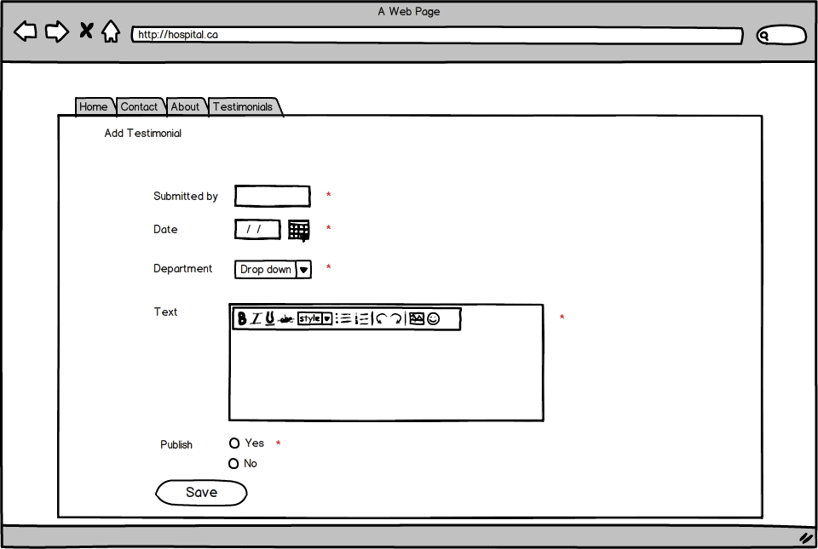

I will expect a more detailed global wireframe from you and your team.

For the feature itself – the form fields are directly based on the database. In this case each input has a corresponding row in the database. You will also note that I have directly marked which fields are mandatory with a red asterisk. I do not agree that just writing “all fields are required” is sufficient. Our users expect something like a red asterisk by each required field. I have also added a formatting bar. You can do the same. There are editing tools you can use, CK Editor is a common one (http://ckeditor.com/) but check with your professors to make sure it is ok to use third party tools like this one.

The pick testimonial from list wireframe will look like this:

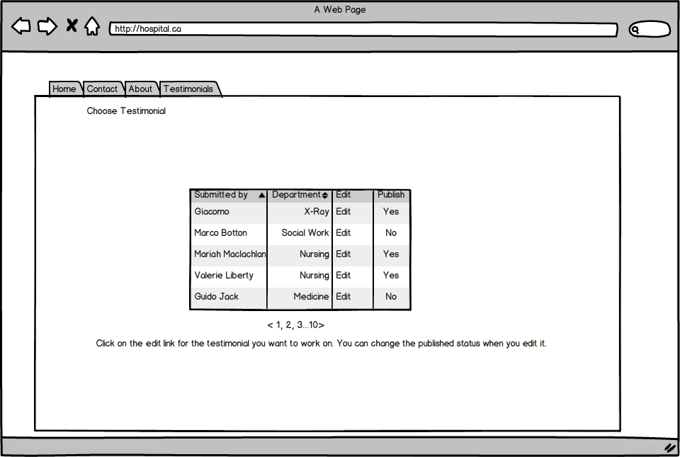

In this wireframe we see the list view of the current testimonials. We do not need the testimonial text here. There are instructions at the bottom of the list. My next wireframe would be to edit the testimonial – which would be almost identical to the add testimonial – except that text would be in the text area.

Overall each interaction between the user and your feature should have a description, a dataflow model, and a wireframe. If the status changes, for example with an error, you would create a new wireframe to reflect the error. You can make one global error wireframe.

Where should you be at the end of today’s class?

You should have one feature complete in draft form. You should have the narrative descriptions ready for the remainder. If you have moved onto the dataflow diagrams for one or two more. Finally, you should have the main wireframe ready so that you can continue to build your documents for the mid-term submission.

